**Research progress**

Updated: 29.08.2013

Number of samples

For simple storage of the sample it would be good to have a sample size witch is a multiple of 8. Due to plate storage capacity a sample size of 64 seams feasible. For the cyro storage of the samples at -80°C it would be good to have a barcode system to organize the samples.

Sector-like structures of colonies

Two initially well-mixed fluorescently labeled strains of E. coli develop a sector like region during expansion of the colonies. This pattern is due to random genetic drift at the expanding frontier.

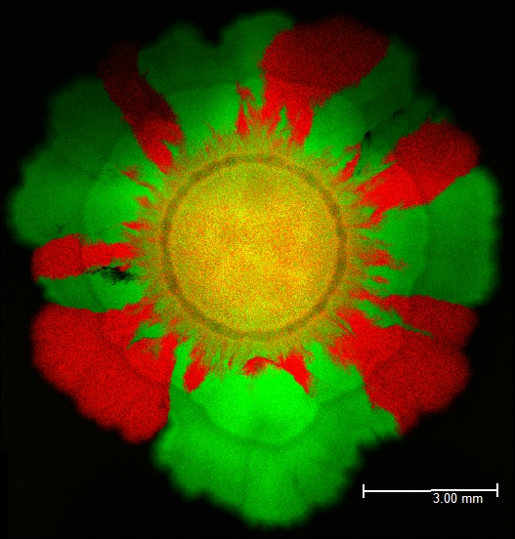

*Status:* completed

**Experiment:** After 24h at 37°C the fluorescently labeled strains of E. coli were incubated for 24h at 45°C.

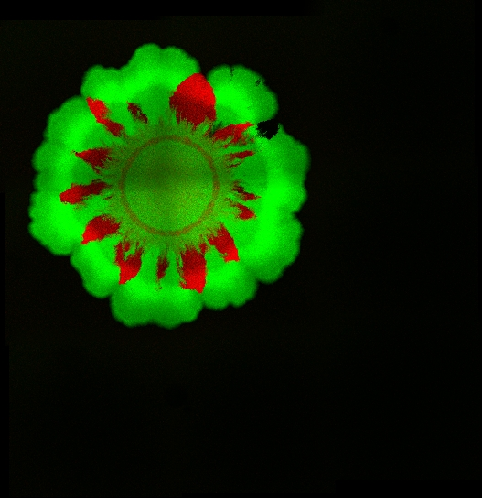

Status: completed

Cell doubling time

It is important to estimate the cell doubling time to compare the range expansion experiment with cells grown in a continuous culture. Hallatschek et al. previously determined the cell doubling time by using time-lapse microscopy of the advancing population front at cellular resolution. At 37°C the generation time was 38 minutes.

The colony should grow on a plate as long as the growth is continuous and the border is regularly. If the expanding speed of the colony is decreasing it should be transferred to a new agar plate.

**Experiment:** The colony forming units (cfu) and the area of the colony were measured over 72h.

*Method:* The cells were grown on LB agar plates and were incubated at 37°C. Cfu's were determined by distributing dilutions of bacterial suspensions on agar plates. After 24 h at 37°C colonies were counted and the concentration was calculated.

*Status:*  completed 10.06.2013

**Outlook:** In the first experiment only the viable cell were counted. All cells could be counted by using flow cytometry.

*Status:* planed

**Outlook:** The generation time could be estimated by using a plasmid that contains a marker (GFP) and replicates only up to a certain temperature (30°C). If the bacteria were incubated at 30°C they would have the plasmid but the replication of the plasmid would stop when they grow at 37°C. The number of plasmid per cell would divide in half for every generation. The generation time could be estimated by measuring the ratio of GFP expressing cell to non- expressing cells over time.

*Status:* planed

Transfer of the colony to a new agar plate

The method to transfer the colonies should be reproducible and not too time consuming. Ideal would be transfer conditions with no growth of the bacteria between the transfers. The concentration should no be too small to avoid a bottleneck effect.

*Protocol:* Cells from the edge of the colony were extracted by using a 1000 ul pipette. The cells were resuspended in 100 ul dilution solution (0.85% NaCl). 1 ul of this solution was transferred to a new agar plate. The remaining solution was incubated in LB media for 24h at 37°C for cyro cultures. Bacteria were incubated at “low mutation rate” conditions to avoid further mutations.

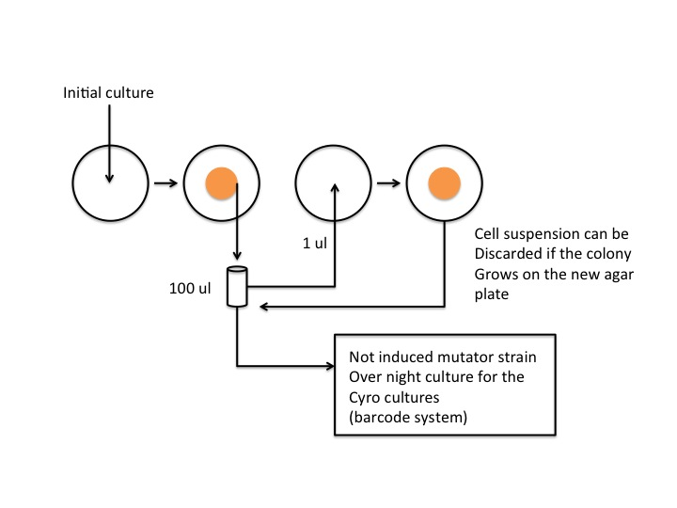

**Experiment:** The cell concentration of the solution was measured over 10 transfers to determine if the number of transferred bacteria is constant over time

Status: in progress

Mutator strain

An inducible mutator strain will be used to decrease the duration of the experiment. Adding L-arabinose leads to induction of the error-prone DNA polymerase dinB. The native chromosomal locus of dinB was modified with an arabinose inducible promotor.

A strain without a DNA mismatch repair system mutS leads also to a higher mutation rate. The DNA mismatch repair system mutS is inducible by adding L-arabinose. These strains should have the same mutation rate as the wild type.

Since it is important to know the mutation rate to plan the duration of the range expansion experiment it would be good to confirm these mutation rates.

**Experiment:** The mutation rate was determined by sequencing induced and non- induced mutator strains, which expanded on agar plates for 10 days. Additionally a chemostat experiment was done for 10 days with these mutator strains.

*Strains:* mutS; without expansion

dinB; without expansion

wt; agar plate

mutS; induced; agar plate

mutS; non-induced; agar plate

dinB; induced; agar plate

dinB; non-induced; agar plate

mutS; induced; chemostat

mutS; non-induced; chemostat

*Methods:* Strains were grown on LB agar plates or in LB media at 37°C. Genomic DNA was extracted by using a promega wizard genomic dna purification kit. The quality of the DNA was checked by gel electrophoresis and by nanodrop. Illumina Sequencing was used to sequence the genomic DNA.

*Status:* in progress 09.2013

Chemostat

To compare the expanding culture with stationary cultures a chemostat could be used. It is important to compare the same amount of generations. Therefore the generation time should also be determined for the chemostat experiment. The protocol for the experiment should be optimized to avoid contaminations during the experiment.

**Experiment:** Test experiment to find the optimal conditions and to determine the generation time.

*Status:* in progress 09.2013

Microfluidic chip

Microfluidic devices can be fabricated from polymers and glass. These devices allow the precise control and manipulation of fluids contained to small channels (10-100 μm) where the fluid flow is dominated by surface tension and laminar effects. Microfluidic chips could be used for range expansion experiments with the following properties:

* Bacterial populations can expand for up to 1000 generations
* Bacteria can be sampled from the chip
* Conditions at the front stay close to constant

The design of the chip would be a long channel without substructure, with a slight flow against which the bacteria would expand

*Status:* planed

DNA switch

A DNA switch could be used to record the behavior of the bacteria on the edge of an expanding population. The protein expression can be changed by an inducible recombinase. By using a low concentration of the inducer only a small proportion of bacteria will change the expression of the fluorescent protein. Therefore, it is possible to determine if the bacteria, which switched the protein expression, can establish on the edge of an expanding population.

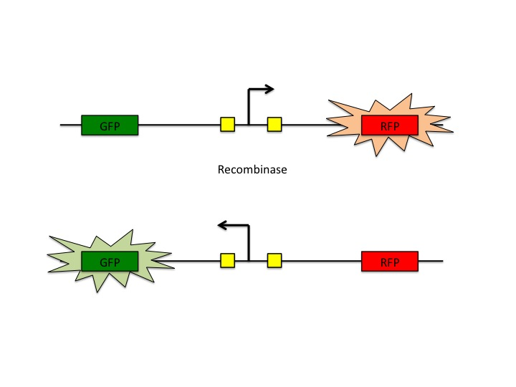

*Status:* planed